spring.servlet.multipart.max-file-size=16MB

spring.servlet.multipart.max-request-size=16MB

mongodb.host=localhost

mongodb.port=27017

mongodb.database=test-db

jar files 8 and 5 packages with file

**public** **class** UserController **extends** LoginController

@EnableMongoRepositories("com.example.polls.repositorysamran")

com.example.polls.zzzocr.

followd this onece

<https://stackoverflow.com/questions/52398308/how-to-use-multiple-mongodb-databases-in-spring-boot-application>

**Here we see the process of the how the jwt are performed and the user register and mongo db register followed by a ocr process in this app with the hit a postman**

First of all we download this from github and import in your IDE like a STS,Eclipse like that.

1. File 🡪 import 🡪 Exist Maven project To a IDE
2. Just Check with the Jar file for the Repo all correctly Downloaded with your Source
3. You must Need a Tessract Official App in your local machine to perform all these properly
4. We Need a IDE,MONGO ,MYSQL . POSTMAN,TESSERACT, APPLICATIONS IN MACHINE
5. Once you imported in IDE , You must create By default Database and two table in your mysql
6. If you want a Any password in your Mysql you can use and update with this application Properties but here we have used without any password in a mysql.
7. Once you created below two table in your mysql we do further process.

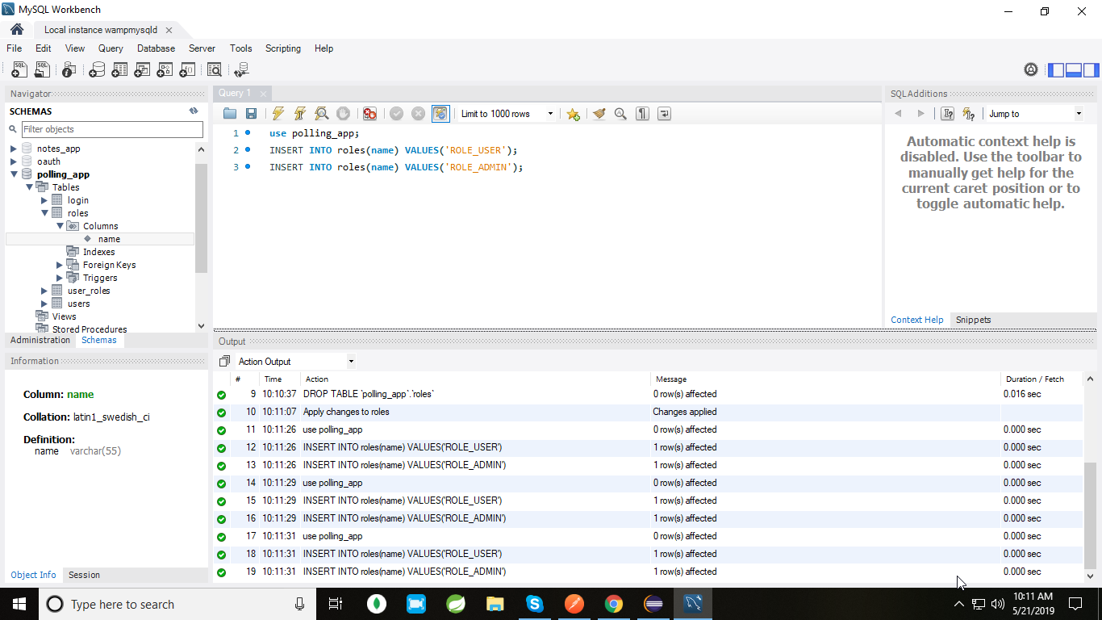

**Ceating Default Roles**

We’ll have a fixed set of predefined roles in our application. Whenever a user logs in, we’ll assign ROLE_USER to it by default.For assigning the roles, they have to be present in the database. So let’s create the two default roles in the database by executing the following insert statements

INSERT INTO roles(name) VALUES('ROLE_USER');

INSERT INTO roles(name) VALUES('ROLE_ADMIN');

Jar files needed for the process ocr

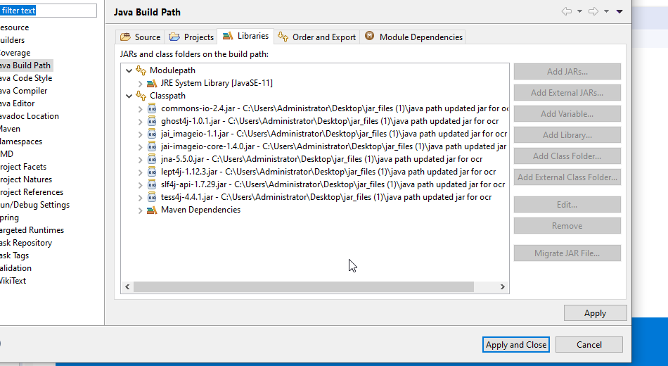

2. Other jar file

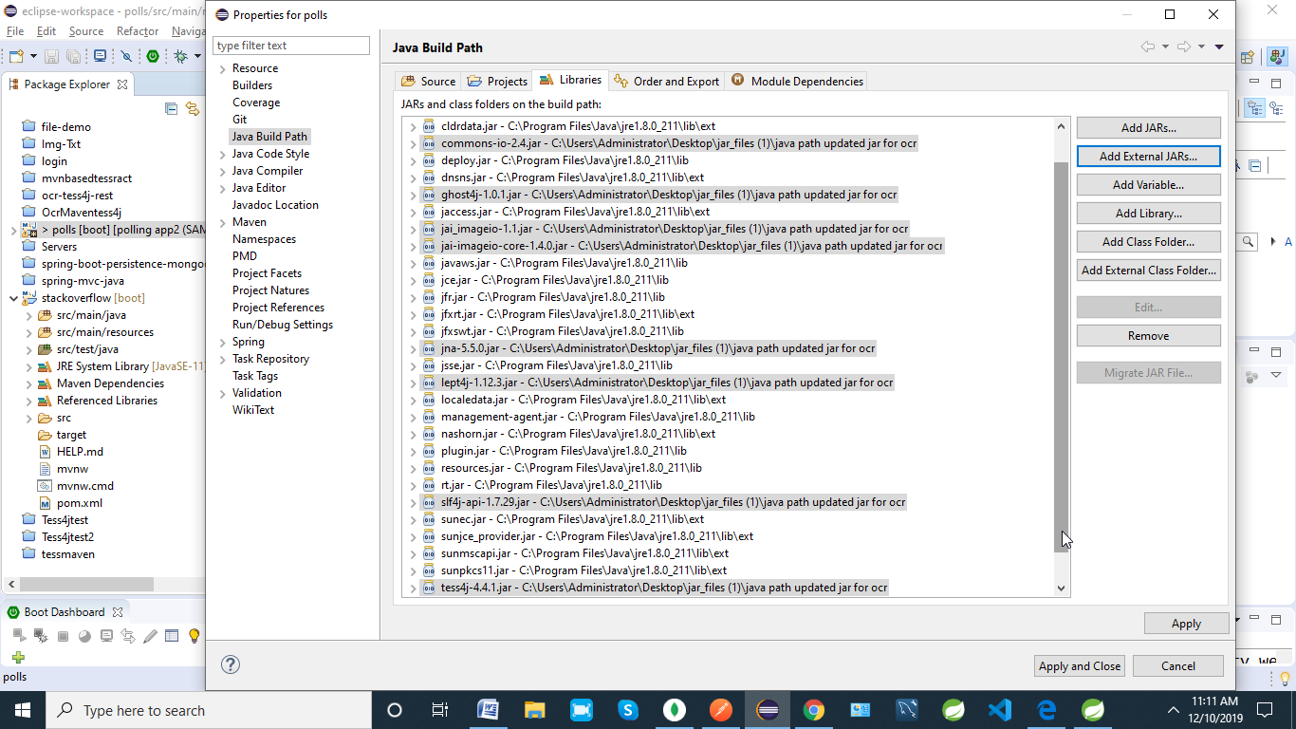

STRUCTURE

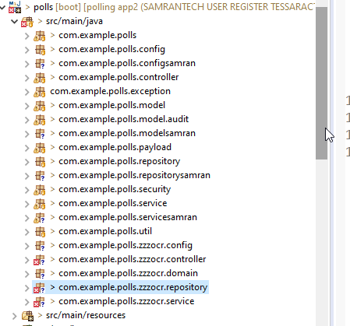

SAMPLE OUTPUT

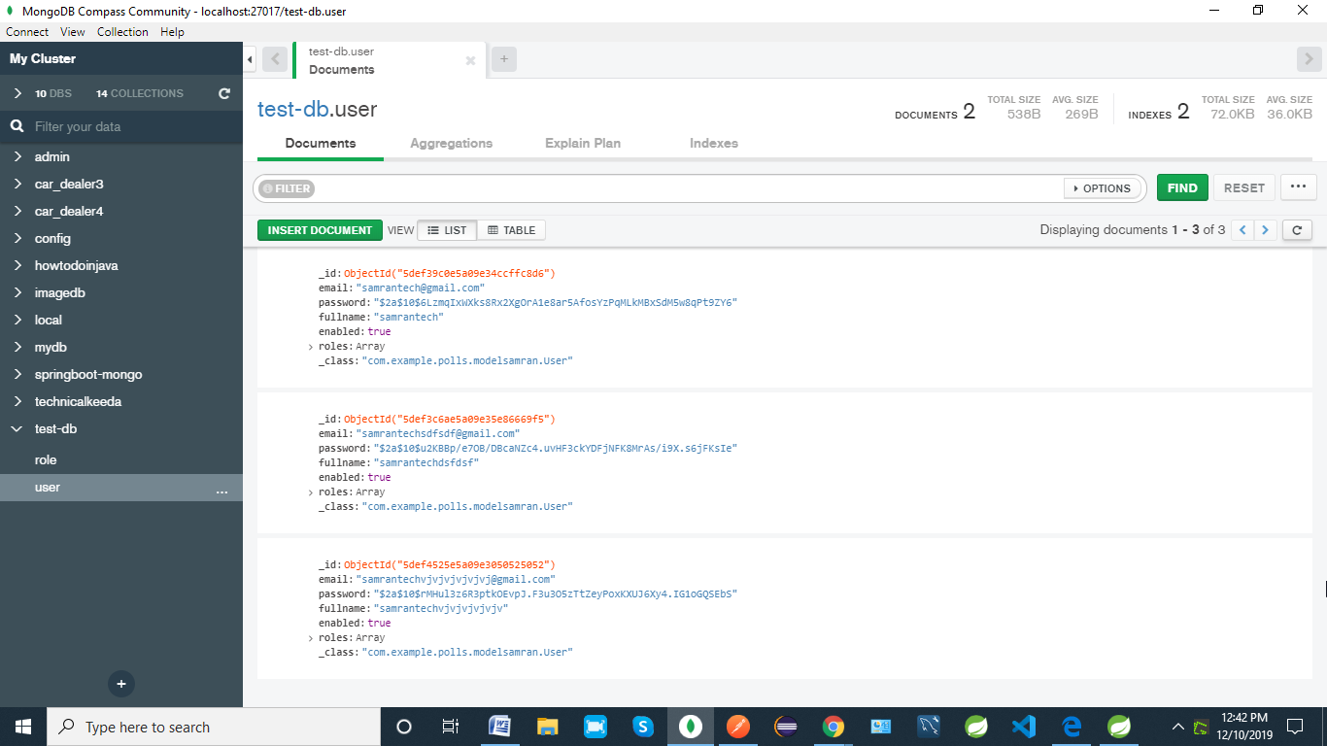

1. First Start App in IDE

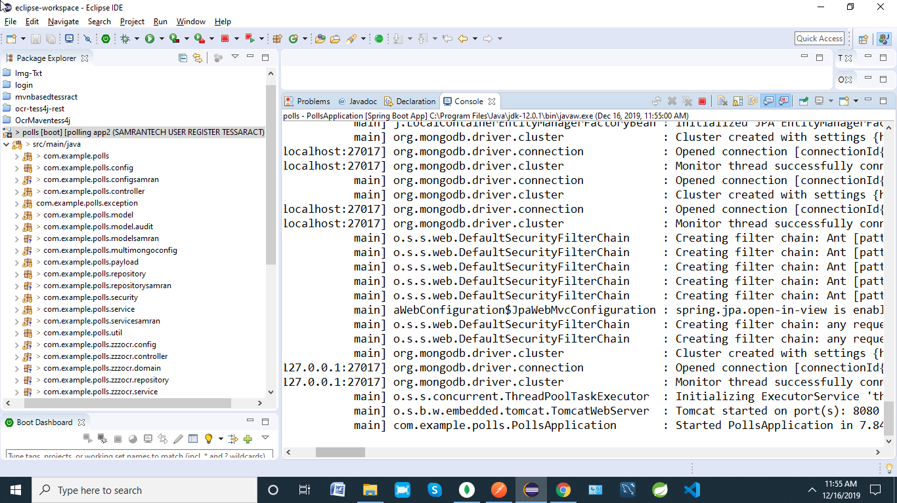

1. While its started the Applications the we perform all out API in a postman App
2. Register with your Name in a body of postman with respected details

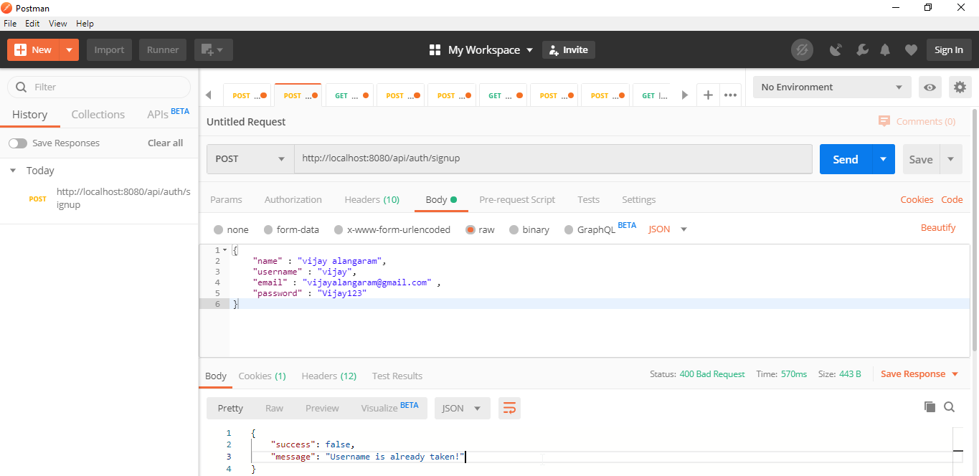

1. Once your register done the used the same details for the login and the access token generation

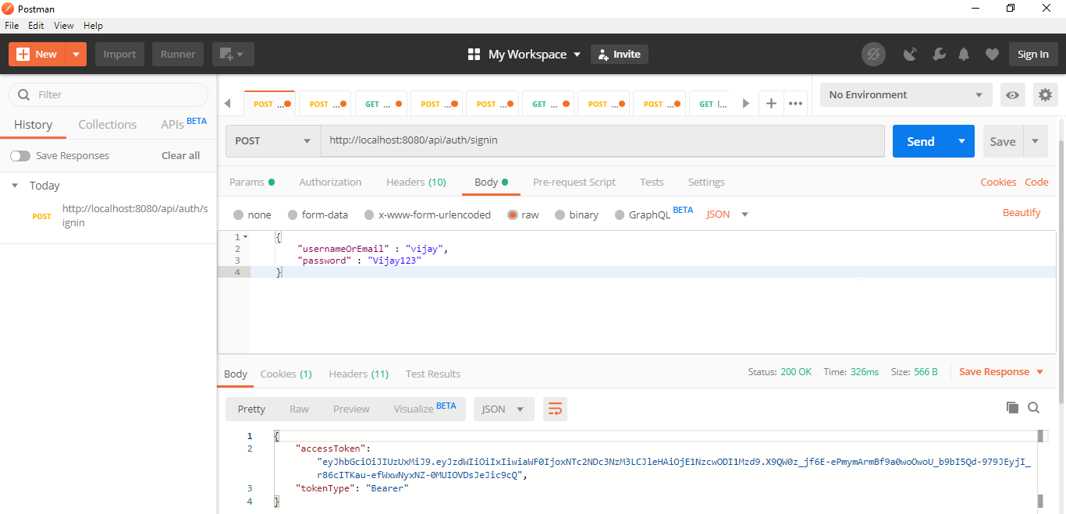

5 . Without access token we can’t perform any process after the login

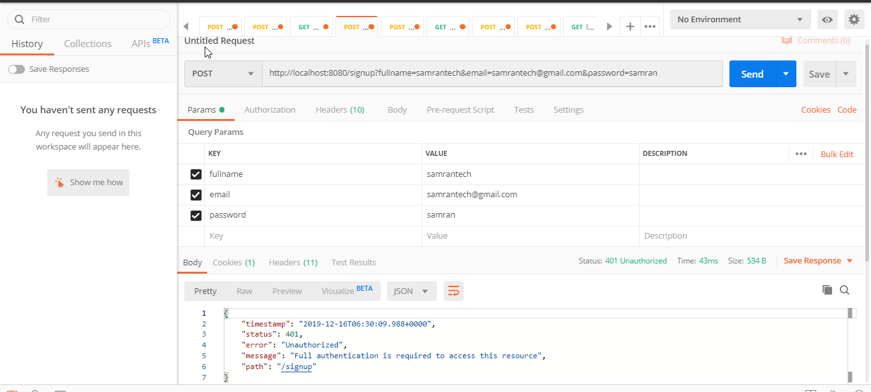

So copied the same access token then perform paste followed by all other APIS

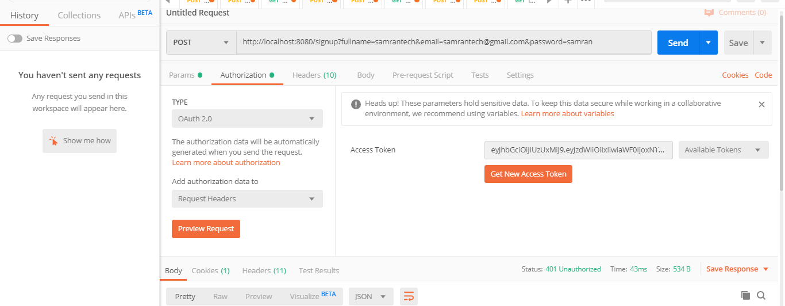

Once you paste the same access token you can do further process like register after the ouath support from mysql for a mongo register

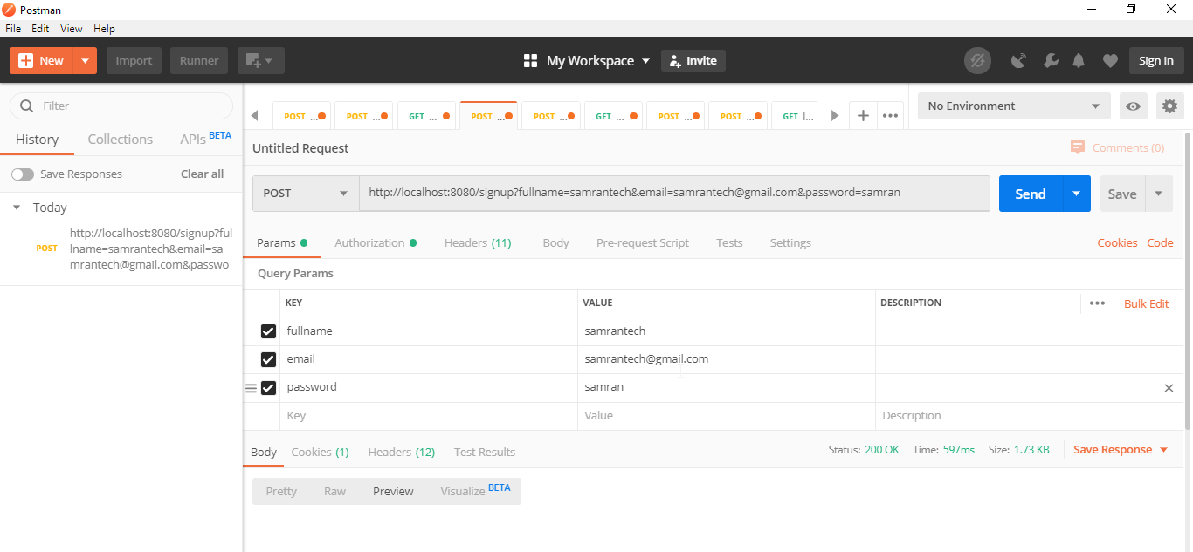

It’s stored in a mongo with secured way to handle the oath support

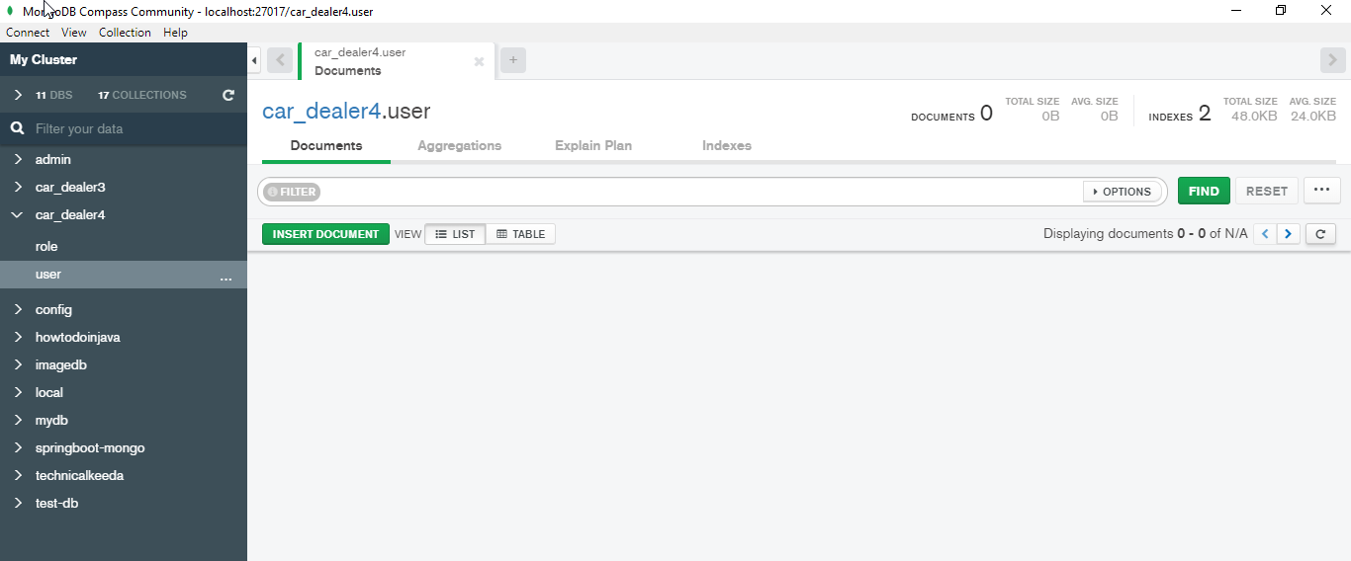

Once you hit the post the values are stored in a mongo successfully

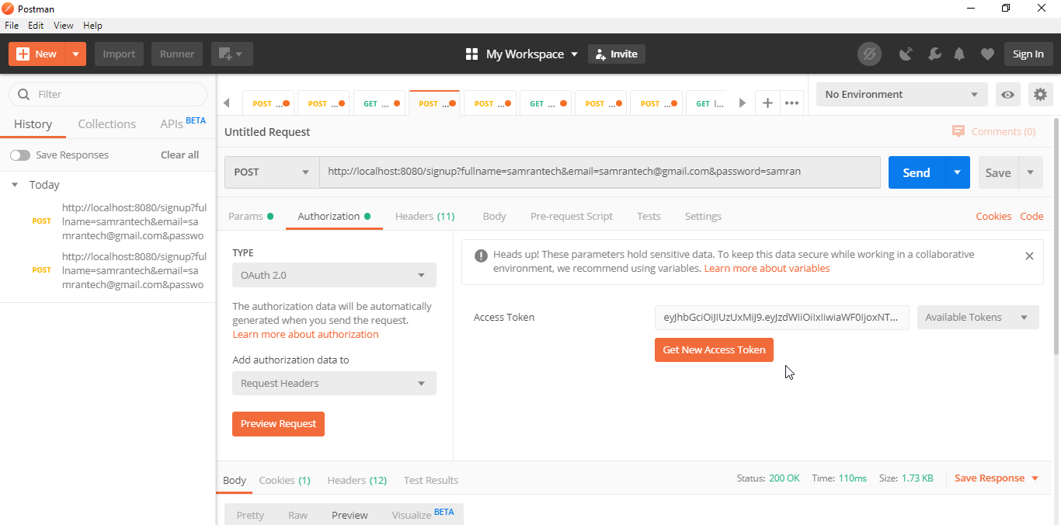

CODE @ 200 Ok

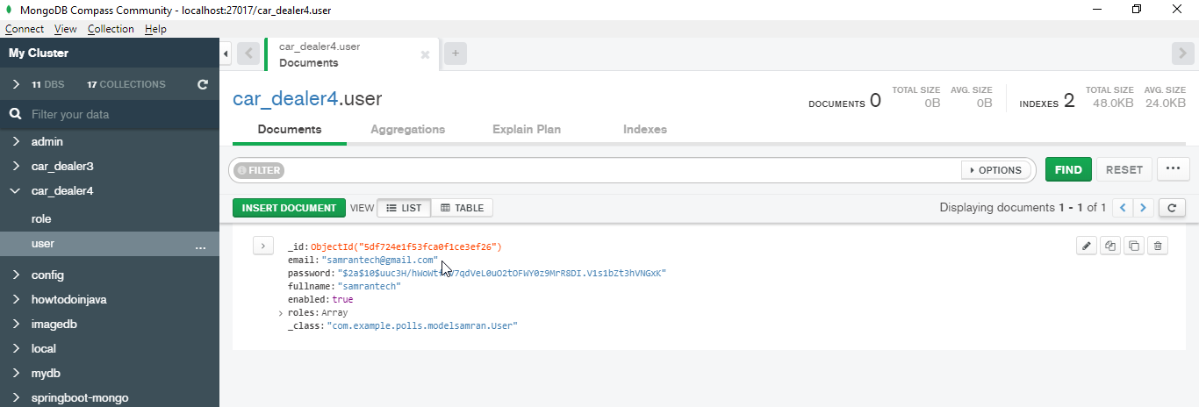

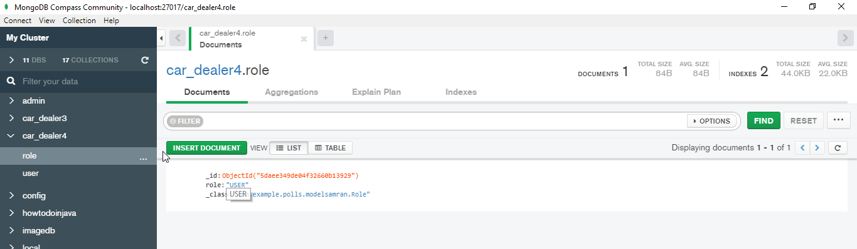

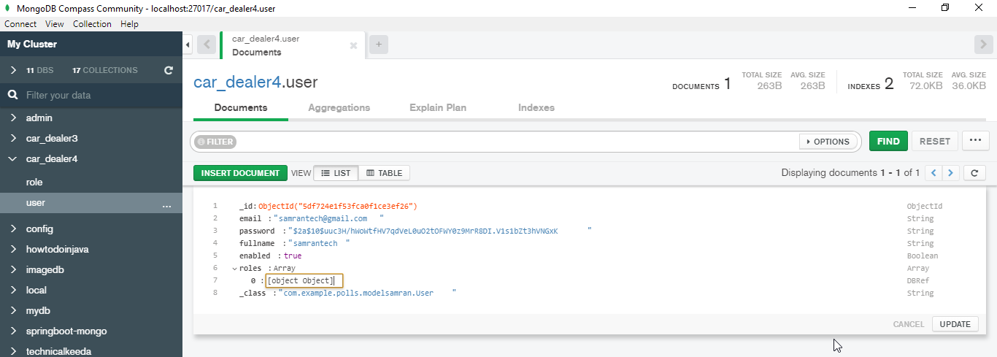

After the register you can check with the same for a login purpose in a mongo but you can use the same access token for a every time of api’s

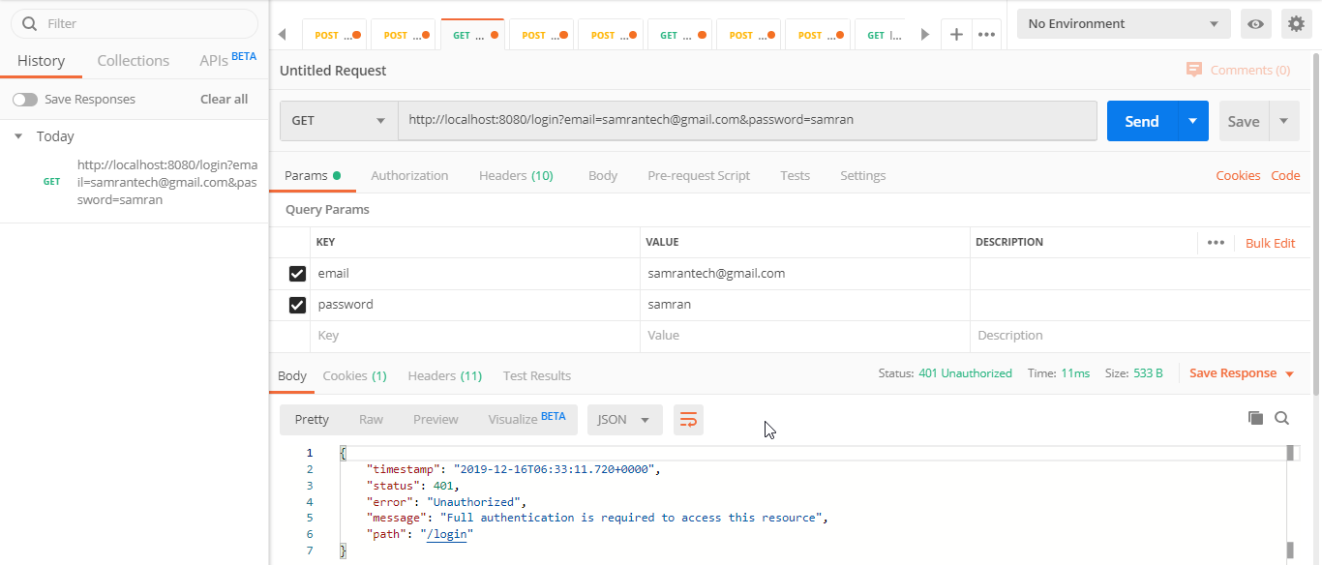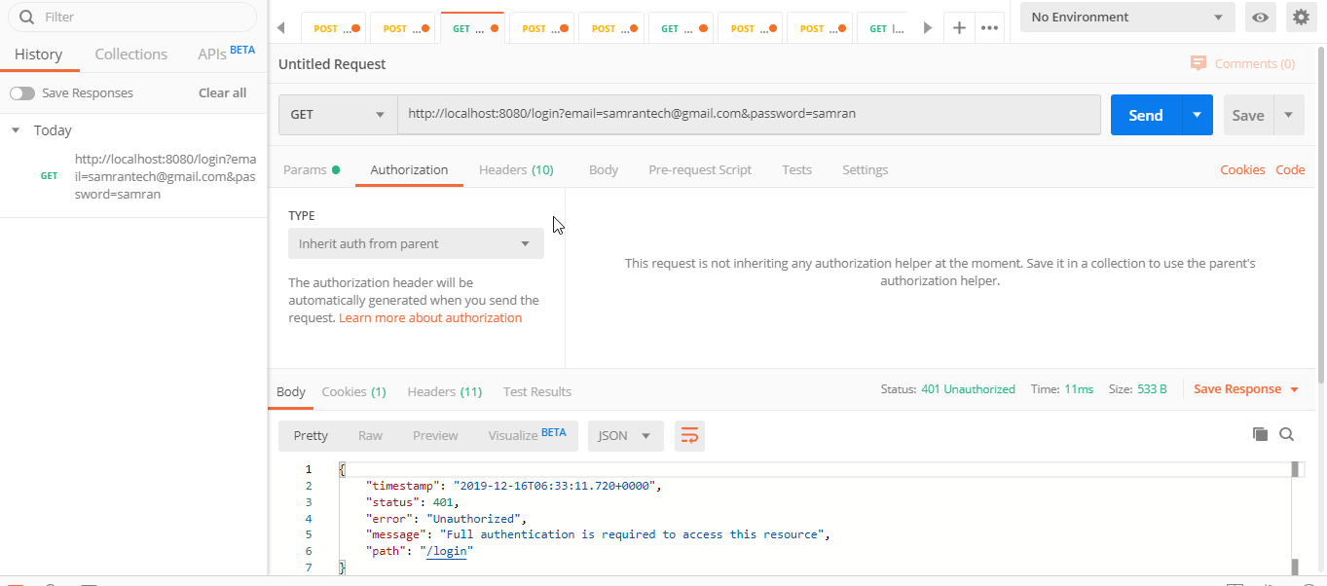

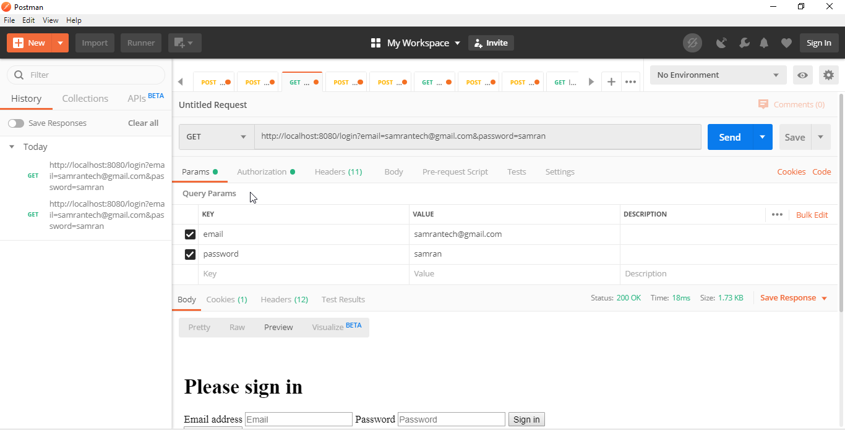

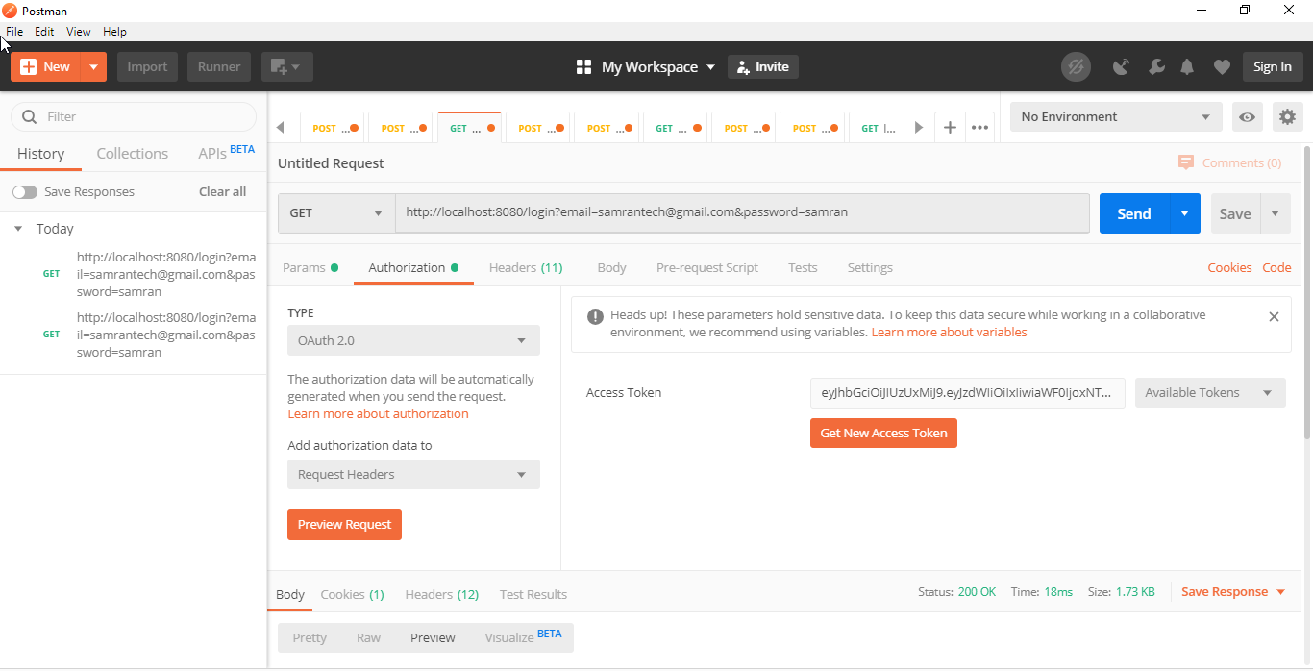

After the successful login you have to perform the ocr image upload and download ,ocr process

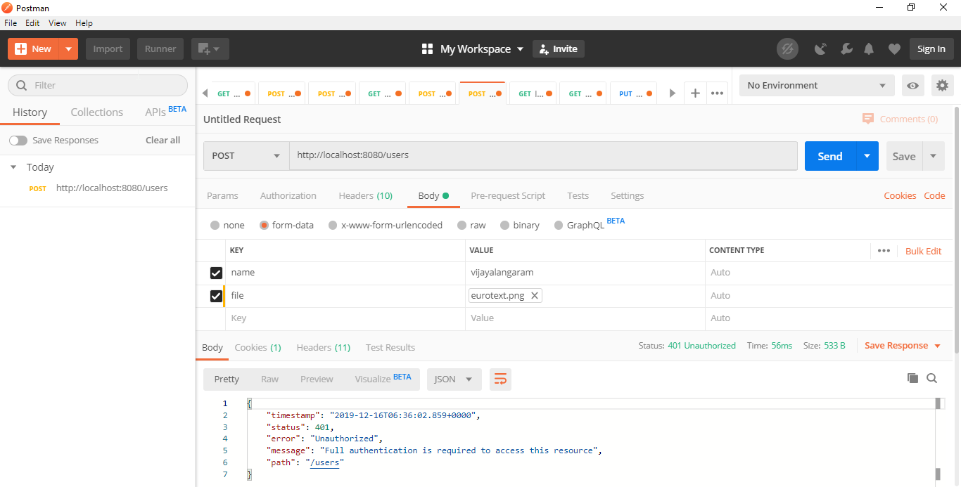

Now we use the same oauth for store a data

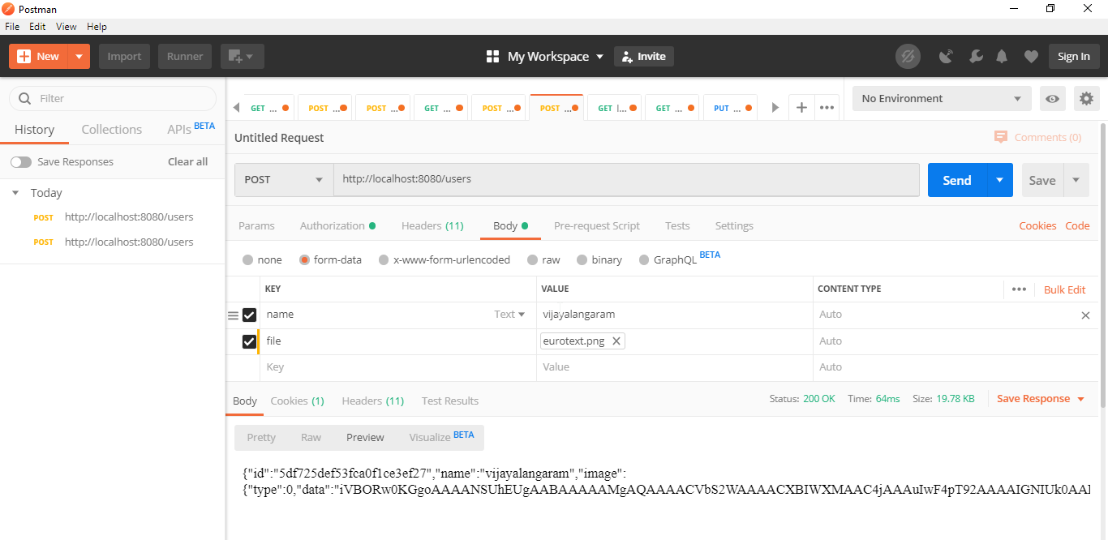

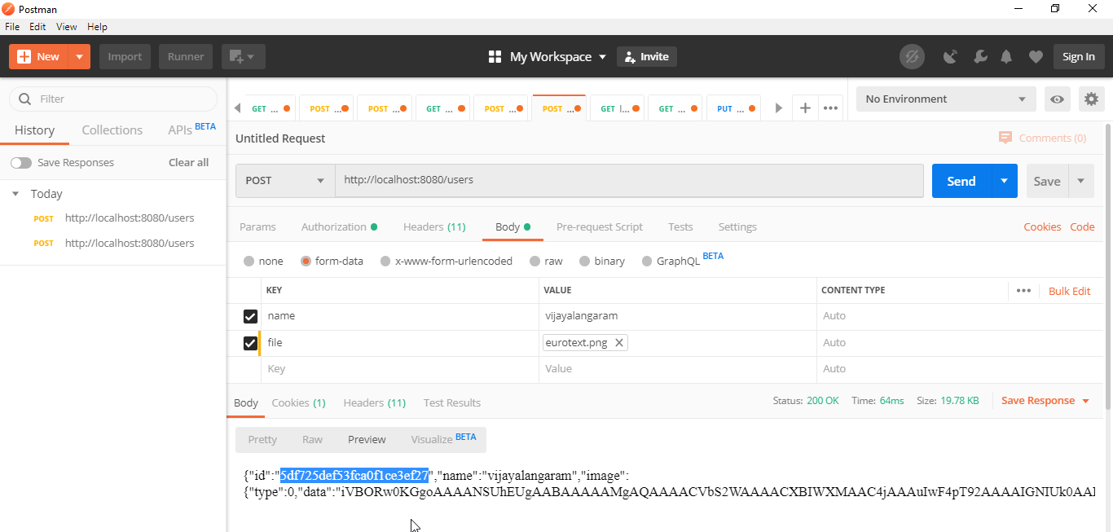

While retrieved from a byte data we can use below

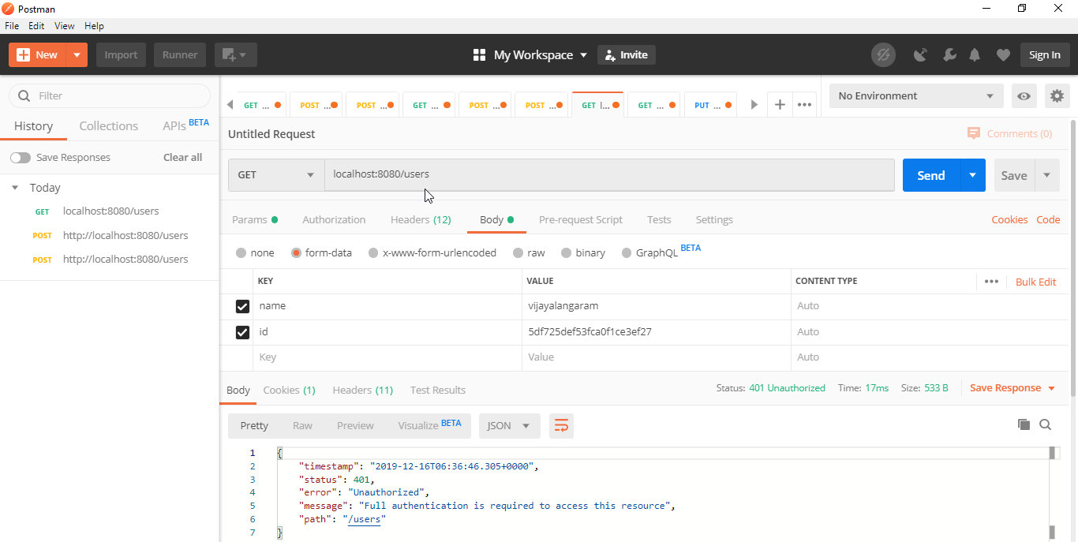

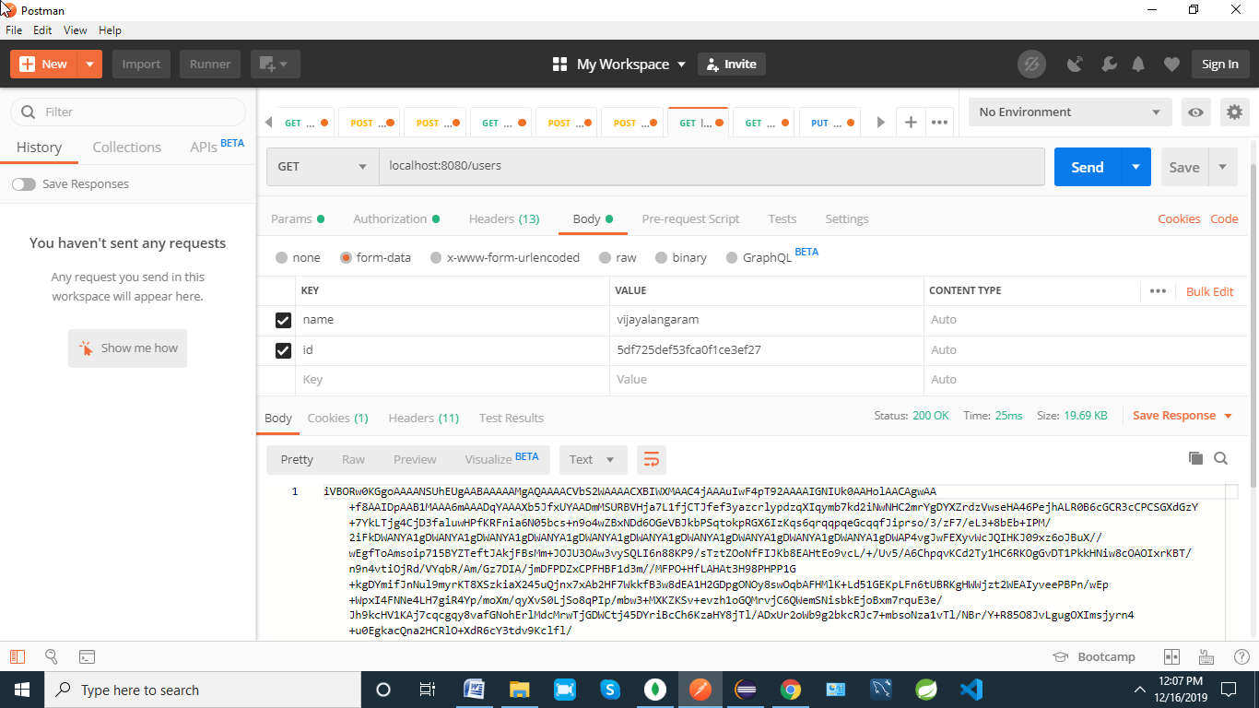

PERFORM A OCR

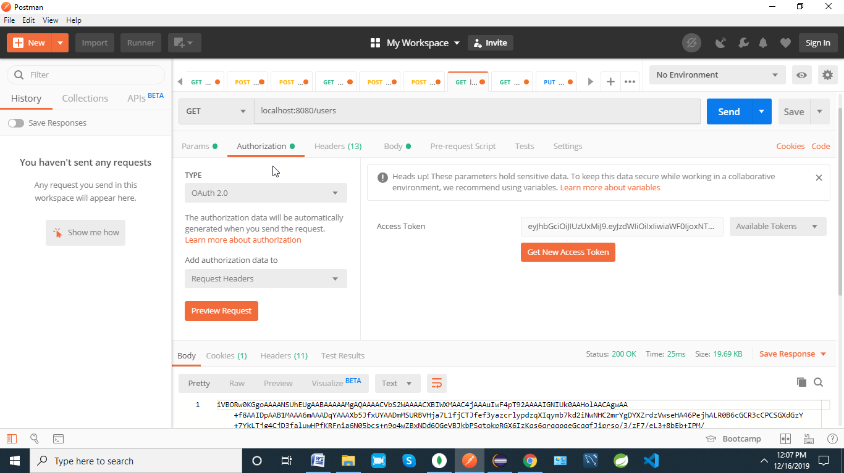

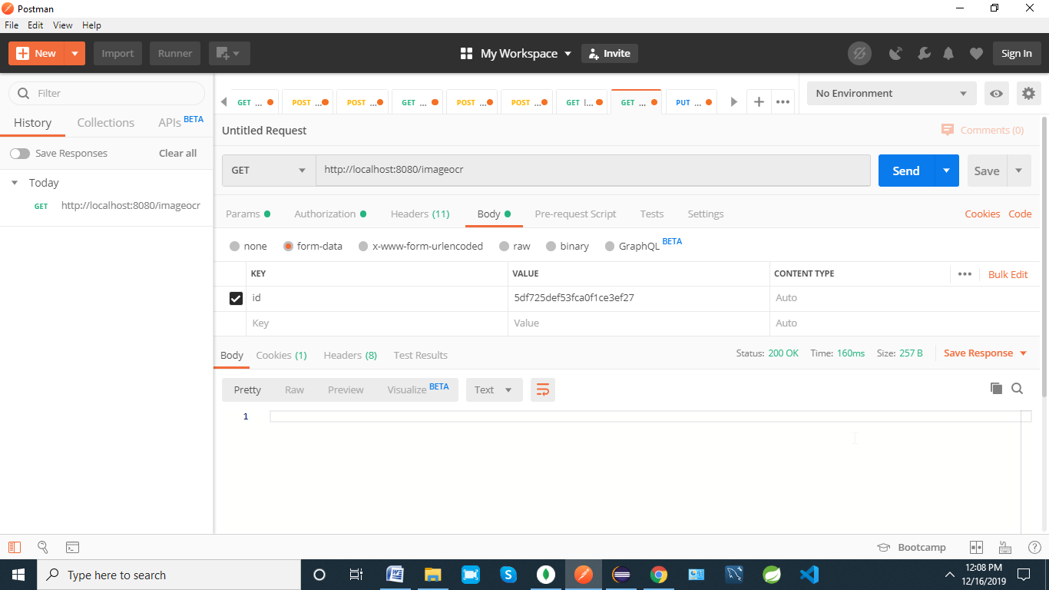

STATUS CODE 200OK

